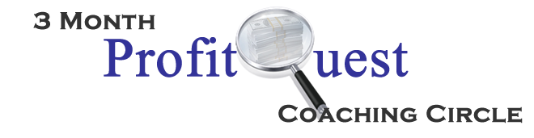

Get excited, because you are going to stretch your capacity to receive profits. Immediately. Ready to begin?

What decision do you have to make right now in order to allow yourself to receive more profits?

What do you want to feel about money 3 months from now?

What is the most important thing you want to accomplish or experience in the next 3 months?

What is your most self-defeating practice around money?

What do you think is the one practice that will most impact your ability to attract more profits?

What 3 structures or systems would serve you most in your business if you were to put them in place now?

What do you most need from me during this program?

Anything else you want me to know?

I’m really looking forward to supporting you at this level.

Please send this form back to me, completed, before our first session: jeanna@masterpeacecoaching.com

In fun, support & profits,
Jeanna

W00T!

